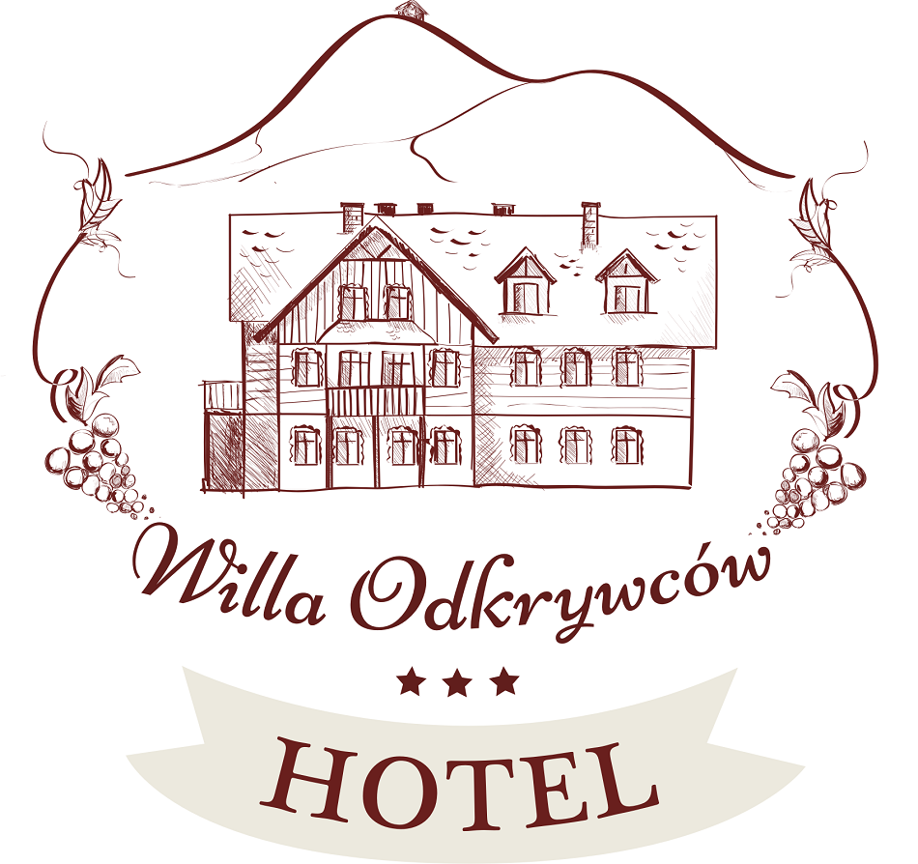  COMPLETE INFORMATION ABOUT PERSONAL DATA  The Willa Odkrywców Hotel*** is the Administrator of personal data of the hotel Guests. The hotel is located in Szklarska Poręba at ul. Okrzei 25, 58-580 Szklarska Poręba. It is owned by ARTCOM Artur Kluszczyński with its registered office in Wrocław at ul. Wałbrzyska 21, 52-314 Wrocław, NIP [Tax Identification Number] PL8942295494.  Purposes of the processing of personal data  The purpose of the processing of personal data by the Hotel*** Willa Odkrywców is to conclude and implement an agreement for the provision of hotel services. Other purposes of the processing of personal data processing by the Hotel are:  - to submit claims by the Hotel in terms of the damage suffered by the Hotel caused by the Guest or defending against claims of the Guest submitted against the Hotel,  - to document and implement the service for tax purposes,  - to provide highest quality services for hotel Guests.  If the Guest has agreed to the processing of personal data for marketing purposes, the Hotel shall process his/her personal data, i.e. to send the Guests marketing information and offers about the products and services of the Hotel.  If the Guest has agreed, the Hotel shall provide opinion providers with the e-mail address specified by the Guest to obtain from the Guest an opinion about the Willa Odkrywców Hotel ***, and post it on the website of the portal. In addition, the Hotel shall collect and process personal data of the Guests using hotel monitoring to ensure safety of the hotel Guests and other people staying at the Hotel.  Legal basics of the processing of personal data  An agreement for the provision of hotel services shall be the legal basis for the processing of personal data of the Guest obtained by the Hotel.  The consent of the Guest shall be the legal basis for the processing of his/her personal data of the Guest used for marketing purposes. The Hotel shall inform that the Guest shall have the right to withdraw his/her consent at any time. Such situation shall not impact on the validity of the processing occurred to withdrawal of the consent. Protection of the vital interests of other individuals and the justified purpose of the administrator shall be the legal basis for the processing of personal data of the Guest by monitoring.  A justified purpose of the administrator to provide the highest quality services for the hotel Guests shall be the legal basis for the processing of personal data of the Guest.  Entities entitled to obtain personal data. Personal data shall be provided by the Hotel to the following categories of entities:  - companies providing the Hotel with IT services and IT software,  - accounting companies providing the Hotel with accounting services,  - transport and taxi companies if the hotel Guest orders transport or courier delivery service,  - legal companies providing the Hotel with legal advisory and representation services,  - companies providing the Hotel with image creating services and opinions about the Willa Odkrywców Hotel***.  Time frame of the processing of personal data.  Personal data:  - obtained in connection with a concluded agreement for the provision of hotel services shall be processed with the prescription period of tax claims or civil law claims of the Hotel or the Guest, whatever occurs later,  - obtained based on the consent shall be processed for the period of validity of this consent,  - obtained based on monitoring shall be processed for 30 days from the recording date, and then shall be permanently deleted.  Rights of the Guest within the processing of personal data. Each Guest shall have the right to access, correct, delete or limit processing of his/her personal data. In addition, each Guest shall have the right to object to the processing. Access to sensitive data shall be possible only at the registered office of the Hotel. In addition, the Hotel shall provide access to its e-mail address willa@willaodkrywcow.pl to contact with the Hotel in terms of personal data.  Possibility to submit a complaint regarding the processing of personal data. Each Guest shall have the right to submit a complaint to the supervisory body, i.e. the General Inspector of Personal Data Protection, ul. Stawki 2, 00-193 Warszawa.  Provision of personal data outside the EEA (European Economic Area). The Hotel shall not intend to provide personal data outside the EEA.  Is the provision of personal data a contractual or statutory requirement? Provision of personal data within full name and address of residence is a requirement to conclude an agreement for the provision of hotel services. Failure to provide personal data shall prevent the Hotel from concluding an agreement for the provision of hotel services.  Automated decisions, including profiling. Personal data shall not be the basis to make automated decisions, including profiling, by the Hotel. | COMPLETE INFORMATION ABOUT PERSONAL DATA  The Willa Odkrywców Hotel*** is the Administrator of personal data of the hotel Guests. The hotel is located in Szklarska Poręba at ul. Okrzei 25, 58-580 Szklarska Poręba. It is owned by ARTCOM Artur Kluszczyński with its registered office in Wrocław at ul. Wałbrzyska 21, 52-314 Wrocław, NIP [Tax Identification Number] PL8942295494.  Purposes of the processing of personal data  The purpose of the processing of personal data by the Hotel*** Willa Odkrywców is to conclude and implement an agreement for the provision of hotel services. Other purposes of the processing of personal data processing by the Hotel are:  - to submit claims by the Hotel in terms of the damage suffered by the Hotel caused by the Guest or defending against claims of the Guest submitted against the Hotel,  - to document and implement the service for tax purposes,  - to provide highest quality services for hotel Guests.  If the Guest has agreed to the processing of personal data for marketing purposes, the Hotel shall process his/her personal data, i.e. to send the Guests marketing information and offers about the products and services of the Hotel.  If the Guest has agreed, the Hotel shall provide opinion providers with the e-mail address specified by the Guest to obtain from the Guest an opinion about the Willa Odkrywców Hotel ***, and post it on the website of the portal. In addition, the Hotel shall collect and process personal data of the Guests using hotel monitoring to ensure safety of the hotel Guests and other people staying at the Hotel.  Legal basics of the processing of personal data  An agreement for the provision of hotel services shall be the legal basis for the processing of personal data of the Guest obtained by the Hotel.  The consent of the Guest shall be the legal basis for the processing of his/her personal data of the Guest used for marketing purposes. The Hotel shall inform that the Guest shall have the right to withdraw his/her consent at any time. Such situation shall not impact on the validity of the processing occurred to withdrawal of the consent. Protection of the vital interests of other individuals and the justified purpose of the administrator shall be the legal basis for the processing of personal data of the Guest by monitoring.  A justified purpose of the administrator to provide the highest quality services for the hotel Guests shall be the legal basis for the processing of personal data of the Guest.  Entities entitled to obtain personal data. Personal data shall be provided by the Hotel to the following categories of entities:  - companies providing the Hotel with IT services and IT software,  - accounting companies providing the Hotel with accounting services,  - transport and taxi companies if the hotel Guest orders transport or courier delivery service,  - legal companies providing the Hotel with legal advisory  and representation services,  - companies providing the Hotel with image creating services  and opinions about the Willa Odkrywców Hotel***.  Time frame of the processing of personal data.  Personal data:  - obtained in connection with a concluded agreement for the provision of hotel services shall be processed with the prescription period of tax claims or civil law claims of the Hotel or the Guest, whatever occurs later,  - obtained based on the consent shall be processed for the period of validity of this consent,  - obtained based on monitoring shall be processed for 30 days from the recording date, and then shall be permanently deleted.  Rights of the Guest within the processing of personal data. Each Guest shall have the right to access, correct, delete or limit processing of his/her personal data. In addition, each Guest shall have the right to object to the processing. Access to sensitive data shall be possible only at the registered office of the Hotel. In addition, the Hotel shall provide access to its e-mail address willa@willaodkrywcow.pl to contact with the Hotel in terms of personal data.  Possibility to submit a complaint regarding the processing of personal data. Each Guest shall have the right to submit a complaint to the supervisory body, i.e. the General Inspector of Personal Data Protection, ul. Stawki 2, 00-193 Warszawa.  Provision of personal data outside the EEA (European Economic Area). The Hotel shall not intend to provide personal data outside the EEA.  Is the provision of personal data a contractual or statutory requirement? Provision of personal data within full name and address of residence is  a requirement to conclude an agreement for the provision of hotel services. Failure to provide personal data shall prevent the Hotel from concluding an agreement for the provision of hotel services.  Automated decisions, including profiling. Personal data shall not be the basis to make automated decisions, including profiling, by the Hotel. | COMPLETE INFORMATION ABOUT PERSONAL DATA  The Willa Odkrywców Hotel*** is the Administrator of personal data of the hotel Guests. The hotel is located in Szklarska Poręba at ul. Okrzei 25, 58-580 Szklarska Poręba. It is owned by ARTCOM Artur Kluszczyński with its registered office in Wrocław at ul. Wałbrzyska 21, 52-314 Wrocław, NIP [Tax Identification Number] PL8942295494.  Purposes of the processing of personal data  The purpose of the processing of personal data by the Hotel*** Willa Odkrywców is to conclude and implement an agreement for the provision of hotel services. Other purposes of the processing of personal data processing by the Hotel are:  - to submit claims by the Hotel in terms of the damage suffered by the Hotel caused by the Guest or defending against claims of the Guest submitted against the Hotel,  - to document and implement the service for tax purposes,  - to provide highest quality services for hotel Guests.  If the Guest has agreed to the processing of personal data for marketing purposes, the Hotel shall process his/her personal data, i.e. to send the Guests marketing information and offers about the products and services of the Hotel.  If the Guest has agreed, the Hotel shall provide opinion providers with the e-mail address specified by the Guest to obtain from the Guest an opinion about the Willa Odkrywców Hotel ***, and post it on the website of the portal. In addition, the Hotel shall collect and process personal data of the Guests using hotel monitoring to ensure safety of the hotel Guests and other people staying at the Hotel.  Legal basics of the processing of personal data  An agreement for the provision of hotel services shall be the legal basis for the processing of personal data of the Guest obtained by the Hotel.  The consent of the Guest shall be the legal basis for the processing of his/her personal data of the Guest used for marketing purposes. The Hotel shall inform that the Guest shall have the right to withdraw his/her consent at any time. Such situation shall not impact on the validity of the processing occurred to withdrawal of the consent. Protection of the vital interests of other individuals and the justified purpose of the administrator shall be the legal basis for the processing of personal data of the Guest by monitoring.  A justified purpose of the administrator to provide the highest quality services for the hotel Guests shall be the legal basis for the processing of personal data of the Guest.  Entities entitled to obtain personal data. Personal data shall be provided by the Hotel to the following categories of entities:  - companies providing the Hotel with IT services and IT software,  - accounting companies providing the Hotel with accounting services,  - transport and taxi companies if the hotel Guest orders transport or courier delivery service,  - legal companies providing the Hotel with legal advisory and representation services,  - companies providing the Hotel with image creating services  and opinions about the Willa Odkrywców Hotel***.  Time frame of the processing of personal data.  Personal data:  - obtained in connection with a concluded agreement for the provision of hotel services shall be processed with the prescription period of tax claims or civil law claims of the Hotel or the Guest, whatever occurs later,  - obtained based on the consent shall be processed for the period of validity of this consent,  - obtained based on monitoring shall be processed for 30 days from the recording date, and then shall be permanently deleted.  Rights of the Guest within the processing of personal data. Each Guest shall have the right to access, correct, delete or limit processing of his/her personal data. In addition, each Guest shall have the right to object to the processing. Access to sensitive data shall be possible only at the registered office of the Hotel. In addition, the Hotel shall provide access to its e-mail address willa@willaodkrywcow.pl to contact with the Hotel in terms of personal data.  Possibility to submit a complaint regarding the processing of personal data. Each Guest shall have the right to submit a complaint to the supervisory body, i.e. the General Inspector of Personal Data Protection, ul. Stawki 2, 00-193 Warszawa.  Provision of personal data outside the EEA (European Economic Area). The Hotel shall not intend to provide personal data outside the EEA.  Is the provision of personal data a contractual or statutory requirement? Provision of personal data within full name and address of residence is  a requirement to conclude an agreement for the provision of hotel services. Failure to provide personal data shall prevent the Hotel from concluding an agreement for the provision of hotel services.  Automated decisions, including profiling. Personal data shall not be the basis to make automated decisions, including profiling, by the Hotel.

